**NUMBER SYSTEM AND REPRESENTATION**

**Binary Representations In Digital Logic**

**45 = 4*101 + 5*100**

**101101 = 1*25 + 0*24 + 1*23 + 1*22 + 0*21 + 1*20**

* **Sign magnitude:** Representing numbers with (+) or (-). This sign is leftmost digit.
* Adding 1 to the front of binary number makes it **-ve** and 0 makes it **+ve**.

**0101101 = +45**

**1101101 = -45**

* It is when only six digits are considered, and leftmost digit represents sign.

**+0 = 0000**

**-0 = 1000**

* This creates problems in computers.
* **Signed number:** Contains both **+ve and -ve** value.
* **Unsigned number:** Contains only **0 or +ve** value.

**Compliments**

**1’s compliment:** Represents **-ve** binary numbers in **signed** environment.

**1111111 – 1010100 = 0101011**

* Can also simply interchange the digits.

**2’s compliment:** Also used to represent **-ve** numbers in signed environment.

* 2’s compliment = 1’s compliment + 1

**IEEE 754:** Technical standard for floating point numbers.

**Bits:** 0 or 1 = 1 bit

**Mantissa:** Bits after decimal point.

**32-Bit Representation Of Real Number**

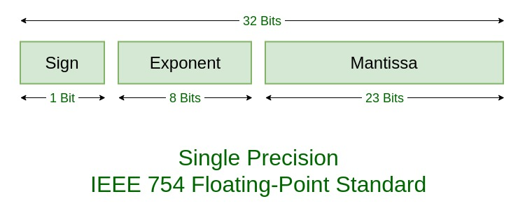

**64-Bit Representation Of Real Number**

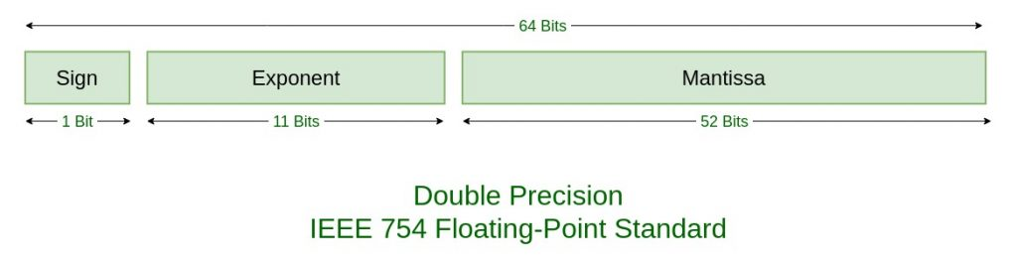

**Number System and Base Conversions**

**Duodecimal:** Base 12

**Uncial:** Base 1/12

**Radix point = Decimal point**

* **MSB:** Leftmost digit in integer part.
* **LSB:** Rightmost digit in fractional part.

**Conversion From One Base To Another**

* Decimal to binary (fractional part)

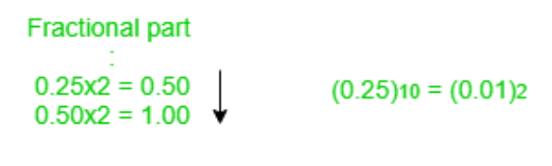

* Binary to hex or oct & vice versa is done by converting 3 bits or 4 bits conversion.

**Floating Point To Decimal**

* Components of bit conversion are **sign**, **exponent** and **mantissa**.
* **Bias:** **2k-1 – 1** where **‘k’** is number of bits held by exponent.
* There are **3 exponent** **bits** in **8-bit** representation.

**Exponent n = Exponent in decimal – Bias in decimal**

**Mantissa = 1 + The remaining bits in decimal**

**Decimal eq. = (-1)sign * mantissa * 2exponent**

**Decimal To Floating Point**

* Again, components are sign, exponent and mantissa.

**Steps:-**

* First, give the MSB as per the sign of number.

**-17 ---> 1**

* Second, the exponent is nearest but smaller 2n number (n is exponent).

**16 = 24 < 17**

**=> n (exponent) = 4**

* Third, represent (bias + exponent) in binary form, at exponent bits.

**(127 + 4)10 = (131)10 = (10000011)2**

* Fourth, convert given number to binary and put decimal point after 1st bit from left, this process is known as normalization.

**(17) = (10001)**

**=> Normalization = 1.0001 * 24**

* Fifth, write fractional part from left in remaining bit and if any bit left, make it 0.

**00010000000000000000000**

* Finally, put all the parts together.

**11000001100010000000000000000000**

**Floating Point Advantages & Disadvantages**

**Advantages**:-

* Wide range of values (represents values with fixed digits)
* Precision (important in medical & engineering calculations)
* Compatibility (hardware & software integration)
* Easy to use (easily guided in programming)

**Disadvantages:-**

* Complexity (can be difficult to understand)
* Rounding errors (mistakes in values)
* Speed (slower than integer operations in old hardware)
* Limited precision (strict number of digits = less useful)